

CAPSTONE PROJECT REPORT
Report 4 – Software Design Document

Automatic Attendance System Based on Real-Time Location and Face Recognition

INSTRUCTOR: BÙI THỊ LOAN
CLASS: SEP490_G16

Team Members:
- Trần Long Khánh | HE176617
- Nguyễn Đình Dũng | HE176518
- Hà Việt Hiếu | HE176256
- Nguyễn Văn Đạt | HE176009
- Kiều Thị Ngọc Dung | HE171203

Table of Contents
I. Record of Changes 6
II. Definitions & Acronyms 7
III. Software Design Document 8
1. System Design 8
1.1 System Architecture 8
1.2 Package Diagram 15
2. Database Design 23
2.1. SQL Database Diagram 23
2.2 NoSQL Database 31
3. Detailed Design 34
3.1. Attendance Calculation 34
3.2. FaceID verification 37
4. Other Detailed Design 39
4.1 AI pipeline 39
4.3 Model Description 42

List of Figures
Figure No. | Title | Page
Figure 1 | Architecture Diagram | 8
Figure 2 | Mobile App | 9
Figure 3 | ASP.NET | 10
Figure 4 | Redis | 11
Figure 5 | PostgreSQL with pgvector | 11
Figure 6 | RabbitMQ | 12
Figure 7 | MartenDB | 13
Figure 8 | Docker | 13
Figure 9 | MediaPipe | 14
Figure 10 | TensorFlow Lite | 14
Figure 11 | Frontend Package Diagram | 15
Figure 12 | Mobile Package Diagram | 18
Figure 13 | Backend Package Diagram | 21
Figure 14 | SQL Database Design | 23
Figure 15 | NoSQL Database Design | 31
Figure 16 | Attendance Calculation class diagram | 34
Figure 17 | Attendance Calculation sequence diagram | 36
Figure 18 | FaceID verification class diagram | 37
Figure 19 | FaceID verification sequence diagram | 38
Figure 20 | FaceID AI pipeline diagram | 39
Figure 21 | FaceID verification activity diagram | 40
Figure 22 | Patchnet learning Anti-spoofting architecture | 42
Figure 23 | META learning Anti-spoofting architecture | 42
Figure 24 | Sample Face Anti-Spoofing Dataset from NUAA | 43
Figure 25 | Sample Real Image - Patch Extraction | 43
Figure 26 | Sample Fake Image - Patch Extraction | 44
Figure 27 | Thermodynamic diagram example of attention mechanism | 44
Figure 28 | Fourier spectrum of face image | 45
Figure 29 | iTracker - Gaze estimation architecture | 48
Figure 30 | FaceNet model structure | 50
Figure 31 | FaceNet model triplet loss | 51

List of Tables
Table No. | Title | Page
Table 1 | Frontend Package Descriptions | 15
Table 2 | Mobile Package Descriptions | 18
Table 3 | Backend Package Descriptions
Table 4 | User Table Description | 21
Table 5 | Account Table Description | 24
Table 6 | User Request Table Description | 24
Table 7 | Device Table TableDescription | 25
Table 8 | Attribute Definition Table Description | 26
Table 9 | Option Table Description | 26
Table 10 | Setting Table Description | 26
Table 11 | User Attribute Table Description | 27
Table 12 | Course Table Description | 27
Table 13 | Class Section Table Description | 27
Table 14 | Enrollment Table Description | 28
Table 15 | Room Table Description | 28
Table 16 | Schedule Table Description | 28
Table 17 | Session Table Description | 29
Table 18 | Round Table Description | 29
Table 19 | Attendance Record Table Description | 30
Table 20 | Face Embedding Description | 30
Table 21 | FaceI ID Verify Request Table Description | 30
Table 22 | Schedule Whitelist Table Description | 31
Table 23 | Scan Log Table Description | 32
Table 24 | Round Track Table Description | 32
Table 25 | Student Track Table Description | 33
Table 26 | Notification Table Description | 34

I. Record of Changes

Date | A*  M, D | In charge | Change Description
12/6/2025 | A | DatNV | Add System Design
13/6/2025 | A | DatNV | Add Component Description, Package Diagram Overall
14/6/2025 | A | DatNV | Add Database Design
16/6/2025 | A | DatNV | Add Mock Detailed Design/Class - Sequence Diagram
22/6/2025 | M | DatNV | Update Database Description
25/6/2025 | M | DatNV | Update Database Description
28/6/2025 | A | DatNV | Add Detailed Design/Class Diagram (1, 2)
29/6/2025 | A | DatNV | Add Detailed Design/Class Diagram (3 -> 14)
12/8/2025 | M | DatNV | Update Database Design
12/8/2025 | M | DatNV | Update Package Diagram
16/8/2025 | M | DatNV | Update Package Diagram
16/8/2025 | M | DatNV | Update Class Diagram
17/8/2025 | M | DatNV | Update Component Description, Database Design
17/8/2025 | A | HieuHV | Add Detailed Design of FaceID
18/8/2025 | M | DatNV | Update ERD Diagram, Architecture Diagram
18/8/2025 | A | HieuHV | Add AI pipeline diagram and models description
*A - Added M - Modified D - Deleted

II. Definitions & Acronyms
The table below contains all definitions of terms and acronyms
No | Acronyms & Abbreviations | Definition
1 | AAS | The Automatic Attendance System Based on Real-Time Location and Face Recognition
2 | API | Application Programming Interface
3 | URL | Uniform Resource Locator
4 | HTTP | Hypertext Transfer Protocol
5 | REST | Representational State Transfer
6 | JWT | JSON Web Token
7 | CQRS | Command Query Responsibility Segregation
8 | CNN | Convolutional Neural Network
9 | RGB | Red Green Blue
10 | FFT | Fast Fourier Transform
11 | AI | Artificial Intelligence
12 | MSE | Mean Squared Error
13 | AUC | Area Under the Curve
14 | EER | Equal Error Rate
15 | MAML | Model-Agnostic Meta-Learning
16 | SFAS | Silent Face Anti-Spoofing
17 | L2 | L2 Norm (Euclidean Norm)
18 | TFLite | TensorFlow Lite

III. Software Design Document

1. System Design

1.1 System Architecture

1.1.1 Architecture Diagram
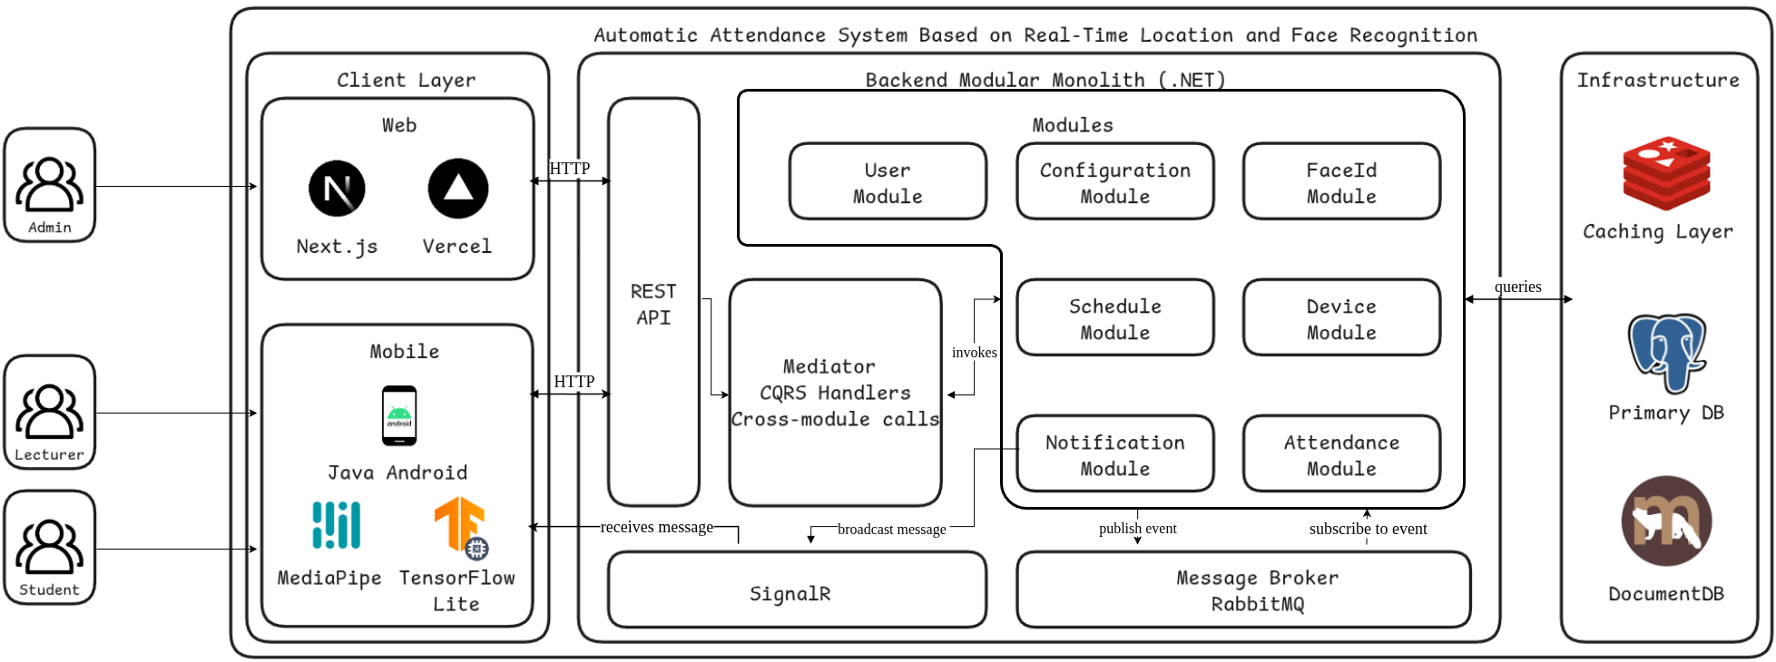
Figure 1 Architecture Diagram

1.1.2 System Architecture Explanation
The Automatic Attendance System comprises a client-side component with dual interfaces: a web application built with Next.js and a mobile application developed in Java Android, alongside a server-side component constructed using ASP.NET Core following a modular monolithic architecture. Communication between clients and servers utilizes REST APIs with comprehensive authentication and authorization through ASP.NET Identity and JWT token-based security. The backend employs the CQRS pattern through a Mediator implementation across multiple business modules including User Management, Attendance Management, Schedule Management, Device Management, FaceID verification, and Notification Services.
For data persistence, the system utilizes a hybrid database approach: PostgreSQL with pgvector extension serves as the primary relational database for structured data and facial embeddings storage, while MartenDB provides document-based storage for attendance tracking data. Redis acts as a caching layer, and RabbitMQ serves as a message broker for asynchronous communication. The mobile application leverages on-device machine learning through MediaPipe and TensorFlow Lite for face recognition processing, enabling offline-first attendance capture with automatic synchronization. Docker containerization ensures consistent deployment across different environments.

1.1.2 Component Description

1.1.2.1 Mobile App
The Android application, developed with Java, serves as the primary end-user interface. It facilitates user interactions and data collection, connecting with the backend via REST APIs to manage all system functionalities. This component is crucial for displaying system information and executing user-driven tasks.

Figure 2 Mobile App

Features and Benefits:
- User Interface (UI): Provides a comprehensive interface for displaying real-time data and system states.
- REST API Integration: Ensures seamless communication with the ASP.NET backend for data exchange.
- Data Collection: Gathers essential information from the end-user environment to be processed by the server.
- Cross-Platform Compatibility: Runs natively on Android, ensuring an optimized user experience.

1.1.2.2 ASP.NET
ASP.NET is the core backend framework, handling all server-side logic and managing system workflows. It coordinates with various other components like Redis, PostgreSQL, and RabbitMQ to ensure robust task execution and service integration.

Figure 3 ASP.NET
Features and Benefits:
- Centralized Logic: Manages all business logic and orchestrates data flow between different modules.
- Component Integration: Acts as a central hub, integrating with Redis for caching, PostgreSQL for data persistence, and RabbitMQ for asynchronous messaging.
- Scalability: Handles high volumes of user requests and complex task executions efficiently.
- Security: Provides a secure environment for all server-side operations and API handling.

1.1.2.3 Redis
Redis is an in-memory data store used as a high-speed cache. It is strategically implemented to enhance performance by storing temporary data, reducing the load on the primary database for frequent queries.

Figure 4 Redis
Features and Benefits:
- Performance Optimization: Drastically reduces latency for high-volume read operations.
- Load Reduction: Offloads traffic from the PostgreSQL database, improving its performance and stability.
- Real-time Data Access: Enables swift retrieval of temporary and frequently accessed data.
- Flexible Data Structures: Supports various data structures, including strings, hashes, and lists, for efficient caching.

1.1.2.4 PostgreSQL with pgvector
PostgreSQL serves as the primary relational database for the system. It is responsible for the persistent storage of all critical data, including user profiles, system configurations, and historical records. By leveraging the pgvector extension, it gains powerful capabilities for handling vector embeddings, which is essential for advanced features like FaceID. Its robust features ensure data integrity and reliable data management.

Figure 5 PostgreSQL with pgvector
Features and Benefits:
- Vector Search for FaceID: The pgvector extension allows for efficient storage and querying of high-dimensional vectors. This is used to store facial recognition embeddings, enabling fast and accurate matches for the FaceID feature.
- Data Integrity: Enforces ACID properties, guaranteeing reliable transactions.
- Complex Querying: Supports advanced SQL queries for detailed data analysis and reporting.
- Reliability: Provides built-in features for data backups and disaster recovery.
- Extensibility: Allows for the use of extensions like pgvector to add new data types and functions, expanding its core capabilities.

1.1.2.5. RabbitMQ
RabbitMQ is a message broker that facilitates asynchronous communication between different components of the ASP.NET backend. It ensures reliable message delivery and decouples services, which is essential for handling high-load scenarios and maintaining system responsiveness.

Figure 6 RabbitMQ
Features and Benefits:
- Asynchronous Processing: Enables the backend to handle long-running or resource-intensive tasks without blocking the main thread.
- Decoupling: Modules can communicate without knowing each other's details, simplifying system architecture.
- Load Distribution: Distributes tasks evenly across different worker processes, ensuring scalability.
- Guaranteed Delivery: Provides robust mechanisms to ensure that messages are processed even if a service fails.

1.1.2.6. MartenDB
MartenDB is utilized as a document database and event store built on top of PostgreSQL. It is particularly effective for managing complex, non-relational data structures like those used for tracking attendance and user activity. By using MartenDB, the project leverages the reliability of PostgreSQL while gaining the flexibility and performance of a document-oriented model.

Figure 7 MartenDB
Features and Benefits:
- Document-Oriented Storage: Stores data as JSON documents, which is ideal for flexible schemas like those for attendance records and user tracks.
- Event Sourcing: Provides built-in support for event sourcing, enabling a reliable audit trail of all changes.
- Native PostgreSQL Integration: Uses PostgreSQL's robust features like transactions and backup, ensuring data durability and integrity.
- Performance: Optimized for high-volume writes and complex queries on document data, complementing the relational data in the main PostgreSQL instance.

1.1.2.7. Docker
Docker is used to containerize the application's components, ensuring consistency across all development, testing, and deployment environments. By isolating each service—like the ASP.NET backend, the PostgreSQL database, and RabbitMQ—into its own container, Docker simplifies the deployment process, improves scalability, and reduces environmental inconsistencies.

Figure 8 Docker
Features and Benefits:
- Environment Consistency: Guarantees that the application runs the same way everywhere, from a developer’s local machine to production servers.
- Scalability: Enables rapid scaling of services by running multiple instances of a container.
- Dependency Isolation: Each container includes its own dependencies, preventing conflicts between services.
- Efficiency: Reduces resource consumption and speeds up deployment cycles by using a lightweight, layered file system.

1.1.2.8. MediaPipe
MediaPipe is used for implementing machine learning solutions for computer vision and perception tasks. It is essential for processing video and image data in real-time to enable features such as face detection, hand tracking, and object recognition within the application.

Figure 9 MediaPipe
Features and Benefits:
- Real-Time Processing: Delivers low-latency performance for live video analysis on mobile devices.
- Cross-Platform: Supports deployment on various platforms, including Android, iOS, and desktop.
- Integrated Solutions: Provides pre-built pipelines for common tasks, simplifying development.
- Robustness: Performs reliably in diverse environmental conditions, handling complex vision-based tasks.

1.1.2.9. TensorFlow Lite
TensorFlow Lite is an optimized version of TensorFlow specifically designed for running machine learning models on mobile and embedded devices. It is integrated to execute models efficiently on the end-user devices, ensuring high performance without requiring a constant network connection.

Figure 10 TensorFlow Lite
Features and Benefits:
- On-Device Machine Learning: Executes models directly on the mobile app, reducing latency and reliance on cloud services.
- Model Optimization: Compresses and optimizes models for size and speed, ideal for resource-constrained devices.
- Offline Capability: Enables machine learning functionalities even when the device is not connected to the internet.
- Hardware Acceleration: Utilizes mobile device hardware to speed up model inference.

1.2 Package Diagram

1.2.1. Frontend Package Diagram
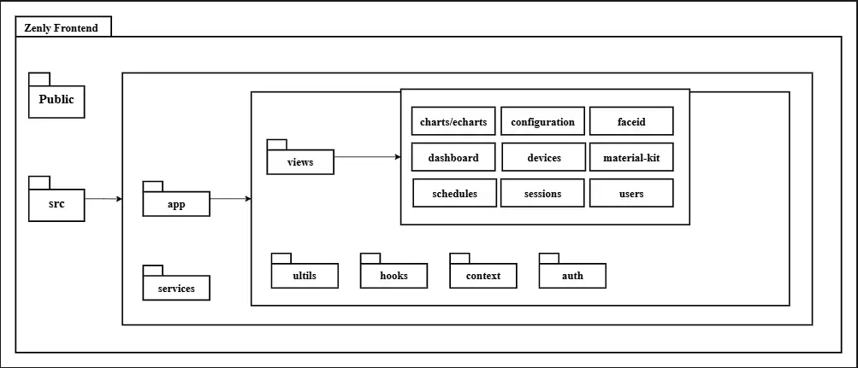
Figure 11 Frontend Package Diagram
Package Descriptions
No | Package |  | Description
01 | public |  | Contains static assets such as images, icons, and configuration files that are directly served by the browser.
02 | src |  | Main source folder of the frontend application, containing all React code, business logic, and supporting modules.
03 | app |  | Application entry point. Defines global layout, routes, theme, and sets up core providers. Acts as the root orchestrator of the frontend.
04 | views | charts/echarts | Provides reusable chart components for analytics and monitoring. Built on ECharts, it supports line, bar, pie, and custom visualizations.
05 | views | configuration | UI module for managing system configurations and runtime settings. Allows administrators to update attributes, options, and preferences.
06 | views | faceid | Interface for face recognition enrollment and verification. Integrates with backend FaceId services for biometric identity checks.
07 | views | dashboard | Main overview page summarizing key system metrics and activities. Offers quick access to core modules with widgets and statistics.
08 | views | devices | Manages device registration, status monitoring, and details. Provides interfaces for authentication, metadata, and whitelist control.
09 | views | material-kit | Contains shared UI components, layouts, and style guides. Ensures consistency in look and feel across all modules.
10 | views | schedules | Manages views for courses, timetables, and room allocations. Allows users to view, create, and update scheduling information.
11 | views | sessions | Displays attendance sessions and tracking information. Provides tools for scanning, logging, and reviewing attendance records.
12 | views | users | Handles user profile management, roles, and permissions. Includes views for registration, authentication, and account settings.
13 | services |  | API service layer that encapsulates HTTP requests and communication with the backend. Provides reusable client-side abstractions for data access.
14 | utils |  | Utility functions and helpers shared across the frontend application.
15 | hooks |  | Custom React hooks that encapsulate reusable stateful logic.
16 | context |  | React Context providers and consumers for managing global application state and cross-cutting concerns.
17 | auth |  | Authentication and authorization handling. Manages login flows, token storage, role-based access, and session state.
Table 1 Frontend Package Descriptions

1.2.2. Mobile Package Diagram

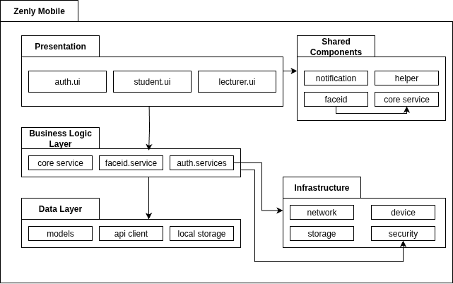
Figure 12 Mobile Package Diagram
Package Descriptions
No | Package |  | Description
01 | Presentation | auth.ui | Provides user authentication screens such as login, registration, and password reset. Ensures secure user onboarding with backend integration.
02 | Presentation | student.ui | UI for students including dashboards, schedules, and attendance views. Designed for simplicity and daily use in managing learning activities.
03 | Presentation | lecturer.ui | UI for lecturers to manage courses, attendance, and class notifications. Focuses on oversight and control features with quick access tools.
04 | Business Logic Layer | core service | Provides core business functions reusable across the app. Handles shared operations like validation, mapping, and state coordination.
05 | Business Logic Layer | faceid.service | Implements biometric recognition logic for secure login and attendance. Encapsulates communication with device cameras and backend verification.
06 | Business Logic Layer | auth.services | Handles authentication workflows, token management, and role-based session state. Ensures smooth user access across multiple roles.
07 | Data Layer | models | Defines data entities and domain models used across the app. Provides a consistent structure for API responses and local persistence.
08 | Data Layer | api client | Responsible for HTTP communication with backend APIs. Manages request building, response parsing, and error handling.
09 | Data Layer | local storage | Stores user sessions, cached data, and offline records. Enables offline-first experience with synchronization to backend.
10 | Shared Components | notification | Provides reusable UI components for push and in-app notifications. Supports alerts, reminders, and contextual system messages.
11 | Shared Components | helper | Utility functions for formatting, calculations, and shared logic. Reduces code duplication across presentation and services.
12 | Shared Components | faceid | Reusable biometric UI and helper functions for multiple flows. Connects face recognition features across modules.
13 | Shared Components | core service | Shared foundational services such as configuration, error handling, and context providers. Accessible by both business logic and UI.
14 | Infrastructure | network | Encapsulates network setup including API base configuration, interceptors, and error retries. Ensures reliable and secure communication.
15 | Infrastructure | storage | Abstracts access to persistent storage. Provides unified APIs for data read/write.
16 | Infrastructure | device | Handles interactions with device hardware. Provides abstraction over native APIs for cross-platform use.
 | Infrastructure | security | Implements encryption, token protection, and secure session handling. Ensures sensitive data is safely stored and transmitted.
Table 2 Mobile Package Descriptions

1.2.3. Backend Package Diagram

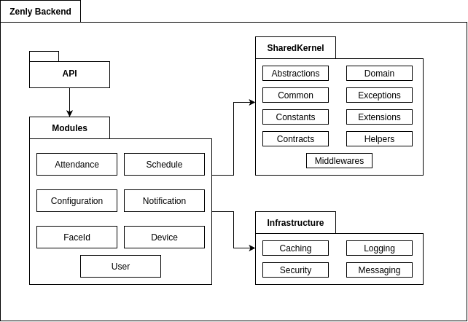
Figure 12 Backend Package Diagram
Package Descriptions
No | Package |  | Description
01 | API |  | Main application entry point exposing HTTP APIs. Configures startup, middleware, DI, and acts as the public gateway to all modules.
02 | Infrastructure |  | Provides cross-cutting infrastructure such as caching, logging, persistence, messaging, and security implementations used by modules.
03 | SharedKernel |  | Contains shared domain primitives, constants, exceptions, contracts, and reusable abstractions for all modules.
04 | Modules | AttendanceManagement | Handles attendance domain including sessions, rounds, scan logs, and attendance records. Provides calculation logic, APIs, and persistence.
05 | Modules | ConfigurationManagement | Manages system configuration such as attributes, settings, and options with scope-based access and runtime updates.
06 | Modules | DeviceManagement | Manages device registration, authentication, metadata, and whitelisting. Ensures secure device integration with other modules.
07 | Modules | FaceId | Provides face biometric storage and verification services, integrating with attendance and device modules for identity checks.
08 | Modules | NotificationService | Orchestrates in-app, push, and email notifications, including templates, delivery channels, and read status tracking.
09 | Modules | ScheduleManagement | Manages courses, class sections, schedules, rooms, and enrollments, integrating with attendance and notifications.
10 | Modules | UserManagement | Handles user accounts, authentication, roles, permissions, and user requests, integrating with other modules for security and workflows.
Table 3 Backend Package Descriptions

2. Database Design

2.1. SQL Database Diagram
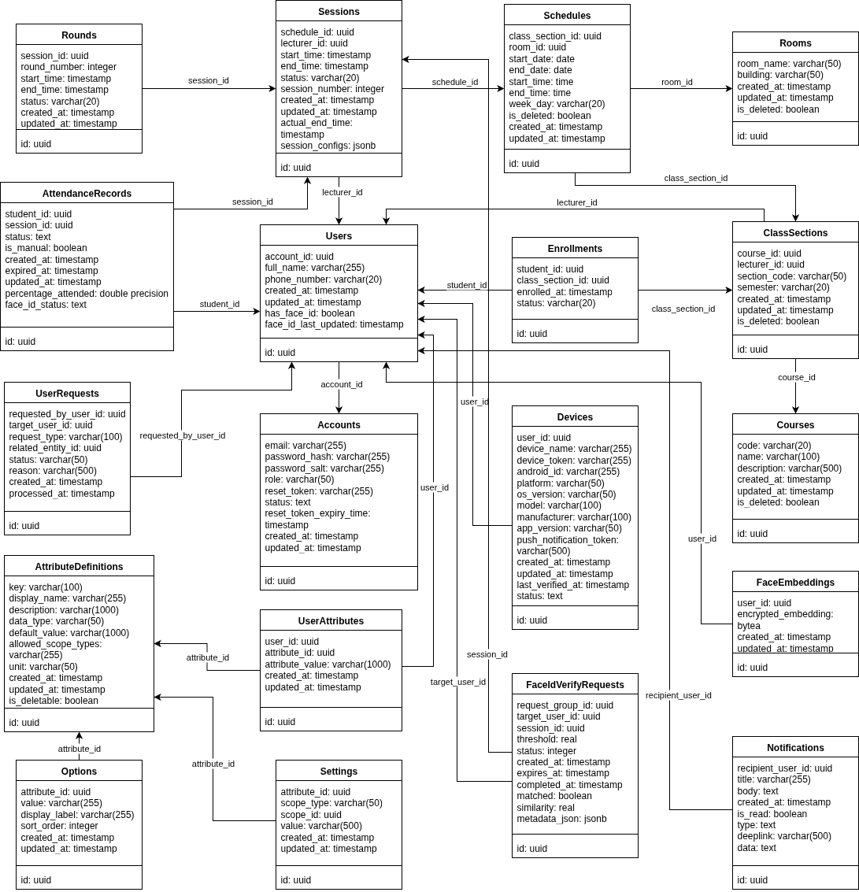
Figure 14 SQL Database Design

Table Description

2.1.1 User
# | Field Name | Type | Constraint | Note
1 | id | uuid | Primary key | Unique identifier
2 | account_id | uuid | Foreign key, Not null | References Account
3 | full_name | varchar(255) | Not null | User's full name
4 | phone_number | varchar(255) |  | User's phone number
5 | has_face_id | boolean | Default: false | Whether face ID data exists
6 | face_id_last_updated | timestamp | Nullable | Last update time of face ID
Table 4 User Table Description

2.1.2 Account
# | Field Name | Type | Constraint | Note
1 | id | uuid | Primary key | Unique identifier
2 | email | varchar(255) | Unique, Not null | Login email
3 | password_hash | varchar(128) | Not null | Hashed password
4 | password_salt | varchar(64) | Not null | Salt for password hashing
5 | role | enum | Not null | Admin / Student / Lecturer
6 | reset_token | varchar(255) | Nullable | Token for password reset
7 | reset_token_expiry_time | timestamp | Nullable | Expiration time of reset token
8 | status | enum | Default: Active | Account status
Table 5 Account Table Description

2.1.3 User Request
# | Field Name | Type | Constraint | Note
1 | id | uuid | Primary key | Unique identifier
2 | requested_by_user_id | uuid | Not null | Requester user ID
3 | target_user_id | uuid | Not null | Target user ID
4 | request_type | enum | Not null | Request type (e.g., AbsentReport)
5 | related_entity_id | uuid | Not null | Related entity ID
6 | status | enum | Default: Pending | Request status
7 | reason | varchar(1000) | Nullable | Reason for the request
8 | processed_at | timestamp | Nullable | Time when request processed
Table 6 User Request Table Description

2.1.4 Device
# | Field Name | Type | Constraint | Note
1 | id | uuid | Primary key | Unique identifier
2 | user_id | uuid | Foreign key, Not null | References User
3 | device_name | varchar(255) | Not null | Name of device
4 | device_token | varchar(255) | Not null | Authentication token
5 | android_id | varchar(255) | Not null | Android device ID
6 | platform | varchar(50) | Nullable | OS platform
7 | os_version | varchar(50) | Nullable | OS version
8 | model | varchar(50) | Nullable | Device model
9 | manufacturer | varchar(50) | Nullable | Device manufacturer
10 | app_version | varchar(50) | Nullable | App version
11 | push_notification_token | varchar(255) | Nullable | Token for push notifications
12 | last_verified_at | timestamp | Nullable | Last token verification time
13 | status | enum | Default: Active | Device status
Table 7 Device Table Description

2.1.5 Attribute Definition
# | Field Name | Type | Constraint | Note
1 | id | uuid | Primary key | Unique identifier
2 | key | varchar(100) | Unique, Not null | Attribute key
3 | display_name | varchar(255) | Not null | Display name
4 | description | varchar(1000) | Nullable | Description of attribute
5 | data_type | enum | Not null | Data type (int/string/bool...)
6 | default_value | varchar(500) | Nullable | Default value
7 | allowed_scope_types | text[] | Not null | List of applicable scopes
8 | unit | varchar(255) | Nullable | Unit of measurement
9 | is_deletable | boolean | Default: true | Whether the attribute can be deleted
Table 8 Attribute Definition Table Description

2.1.6 Option
# | Field Name | Type | Constraint | Note
1 | id | uuid | Primary key | Unique identifier
2 | attribute_id | uuid | Foreign key, Not null | References AttributeDefinition
3 | value | varchar(255) | Not null | Option value
4 | display_label | varchar(255) | Not null | Display label
5 | sort_order | int | Default: 0 | Display order
Table 9 Option Table Description

2.1.7 Setting
# | Field Name | Type | Constraint | Note
1 | id | uuid | Primary key | Unique identifier
2 | attribute_id | uuid | Foreign key, Not null | References AttributeDefinition
3 | scope_type | enum | Not null | Scope type
4 | scope_id | uuid | Not null | Scope identifier
5 | value | varchar(255) | Nullable | Setting value
Table 10 Setting Table Description

2.1.8 User Attribute
# | Field Name | Type | Constraint | Note
1 | id | uuid | Primary key | Unique identifier
2 | user_id | uuid | Foreign key, Not null | References User
3 | attribute_id | uuid | Foreign key, Not null | References AttributeDefinition
4 | attribute_value | varchar(255) | Nullable | Attribute value
Table 11 User Table Attribute Description

2.1.9 Course
# | Field Name | Type | Constraint | Note
1 | id | uuid | Primary key | Unique identifier
2 | code | varchar(50) | Not null | Course code
3 | name | varchar(255) | Not null | Course name
4 | description | varchar(1000) | Nullable | Course description
5 | is_deleted | boolean | Default: false | Soft delete flag
Table 12 Course Table Description

2.1.10 Class Section
# | Field Name | Type | Constraint | Note
1 | id | uuid | Primary key | Unique identifier
2 | course_id | uuid | Foreign key, Not null | References Course
3 | lecturer_id | uuid | Nullable | Lecturer assigned
4 | section_code | varchar(50) | Not null | Section code
5 | semester | varchar(4) | Not null | Semester (e.g., "2024")
6 | is_deleted | boolean | Default: false | Soft delete flag
Table 13 Class Section Table Description

2.1.11 Enrollment
# | Field Name | Type | Constraint | Note
1 | id | uuid | Primary key | Unique identifier
2 | student_id | uuid | Not null | Student ID
3 | class_section_id | uuid | Foreign key, Not null | References ClassSection
4 | enrolled_at | timestamp | Not null | Enrollment time
5 | status | enum | Default: Active | Enrollment status
Table 14 Enrollment Table Description

2.1.12 Room
# | Field Name | Type | Constraint | Note
1 | id | uuid | Primary key | Unique identifier
2 | room_name | varchar(100) | Not null | Room name
3 | building | varchar(100) | Not null | Building name
4 | capacity | int | Not null | Room capacity
5 | is_deleted | boolean | Default: false | Soft delete flag
Table 15 Room Table Description

2.1.13 Schedule
# | Field Name | Type | Constraint | Note
1 | id | uuid | Primary key | Unique identifier
2 | class_section_id | uuid | Foreign key, Not null | References ClassSection
3 | room_id | uuid | Foreign key, Not null | References Room
4 | start_date | date | Not null | Start date
5 | end_date | date | Not null | End date
6 | start_time | time | Not null | Start time
7 | end_time | time | Not null | End time
8 | week_day | enum | Not null | Day of the week
9 | is_deleted | boolean | Default: false | Soft delete flag
Table 16 Schedule Table Description

2.1.14 Session
# | Field Name | Type | Constraint | Note
1 | id | uuid | Primary key | Unique identifier
2 | schedule_id | uuid | Foreign key, Not null | References Schedule
3 | lecturer_id | uuid | Nullable | Lecturer ID
4 | start_time | timestamp | Not null | Session start time
5 | end_time | timestamp | Not null | Session end time
6 | status | enum | Not null | Session status
7 | session_number | int | Not null | Sequence number
8 | actual_end_time | timestamp | Nullable | Real end time
9 | session_configs | jsonb | Not null | Configuration snapshot
Table 17 Session Table Description

2.1.15 Round
# | Field Name | Type | Constraint | Note
1 | id | uuid | Primary key | Unique identifier
2 | session_id | uuid | Foreign key, Not null | References Session
3 | round_number | int | Not null | Round order
4 | start_time | timestamp | Not null | Start time
5 | end_time | timestamp | Not null | End time
6 | status | enum | Not null | Round status
Table 18 Round Table Description

2.1.16 Attendance Record
# | Field Name | Type | Constraint | Note
1 | id | uuid | Primary key | Unique identifier
2 | student_id | uuid | Not null | Student ID
3 | session_id | uuid | Foreign key, Not null | References Session
4 | status | enum | Not null | Attendance status
5 | is_manual | boolean | Not null | Marked manually
6 | expired_at | timestamp | Not null | Expiration time
7 | percentage_attended | double | Not null | Attendance percentage
Table 19 Attendance Record Table Description

2.1.17 Face Embedding
# | Field Name | Type | Constraint | Note
1 | id | uuid | Primary key | Unique identifier
2 | user_id | uuid | Foreign key, Not null | References User
3 | encrypted_embedding | binary | Not null | Encrypted face embedding vector
Table 20 Face Embedding Table Description

2.1.18 Face ID Verify Request
# | Field Name | Type | Constraint | Note
1 | id | uuid | Primary key | Unique identifier
3 | request_group_id | uuid | Not nul | Group request indentifier
2 | student_id | uuid | Foreign key, Not null | References User Student
3 | lecture_id | uuid | Foreign key, Not nul | References User Lecture
4 | session_id | uuid | Not nul | References Session
5 | status | int | Not nul | Status of request
6 | matched | boolean | Not nul | Verification request status
7 | completed_at | Datetime | Not nul | Complete request time
8 | similarity | double | Not nul | Similarity between embedding
Table 21 FaceI ID Verify Request Table Description

2.2 NoSQL Database
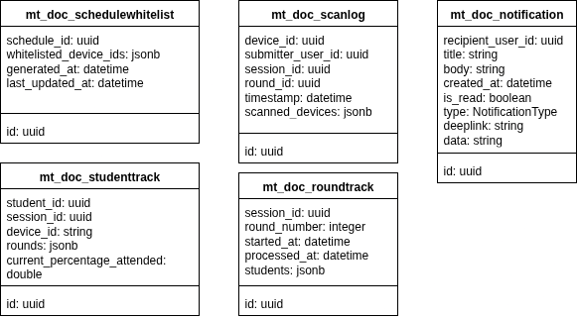
Figure 15 NoSQL Database Design
Table Description

2.2.1 Schedule Whitelist
# | Field Name | Type | Constraint | Note
1 | id | uuid | Primary key | Unique identifier
2 | schedule_id | uuid | Foreign key, Not null | References Schedule
3 | whitelisted_device_ids | uuid[] | Not null | Allowed devices
4 | generated_at | timestamp | Not null | Generation time
5 | last_updated_at | timestamp | Nullable | Last update time
Table 22 ScheduleWhitelist Description

2.2.2 Scan Log
# | Field Name | Type | Constraint | Note
1 | id | uuid | Primary key | Unique identifier
2 | device_id | uuid | Not null | Device ID
3 | submitter_user_id | uuid | Not null | Submitter ID
4 | session_id | uuid | Foreign key, Not null | References Session
5 | round_id | uuid | Foreign key, Not null | References Round
6 | timestamp | timestamp | Not null | Scan time
7 | scanned_devices | jsonb | Nullable | List of scanned devices
Table 23 Scan Log Description

2.2.3 Round Track
# | Field Name | Type | Constraint | Note
1 | id | uuid | Primary key | Unique identifier
2 | session_id | uuid | Foreign key, Not null | References Session
3 | round_number | int | Not null | Round order
4 | started_at | timestamp | Not null | Start time
5 | processed_at | timestamp | Nullable | Processing completed time
6 | students | jsonb | Nullable | Students in this round
Table 24 Round Track Description

2.2.4 Student Track
# | Field Name | Type | Constraint | Note
1 | id | uuid | Primary key | Unique identifier
2 | student_id | uuid | Not null | Student ID
3 | session_id | uuid | Foreign key, Not null | References Session
4 | device_id | varchar(255) | Not null | Student's device ID
5 | rounds | jsonb | Nullable | Participated rounds
6 | current_percentage_attended | double | Not null | Current attendance percentage
Table 25 Student Track Description

2.2.5 Notification
# | Field Name | Type | Constraint | Note
1 | id | uuid | Primary key | Unique identifier
2 | recipient_user_id | uuid | Not null | Recipient user ID
3 | title | varchar(255) | Not null | Notification title
4 | body | text | Not null | Notification content
5 | is_read | boolean | Default: false | Read status
6 | data | jsonb | Nullable | Attached data
Table 26 Notification

3. Detailed Design

3.1. Attendance Calculation

3.1.1. Class diagram
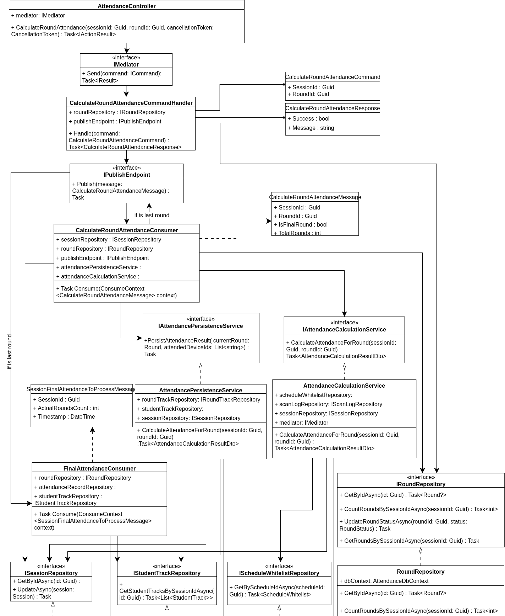
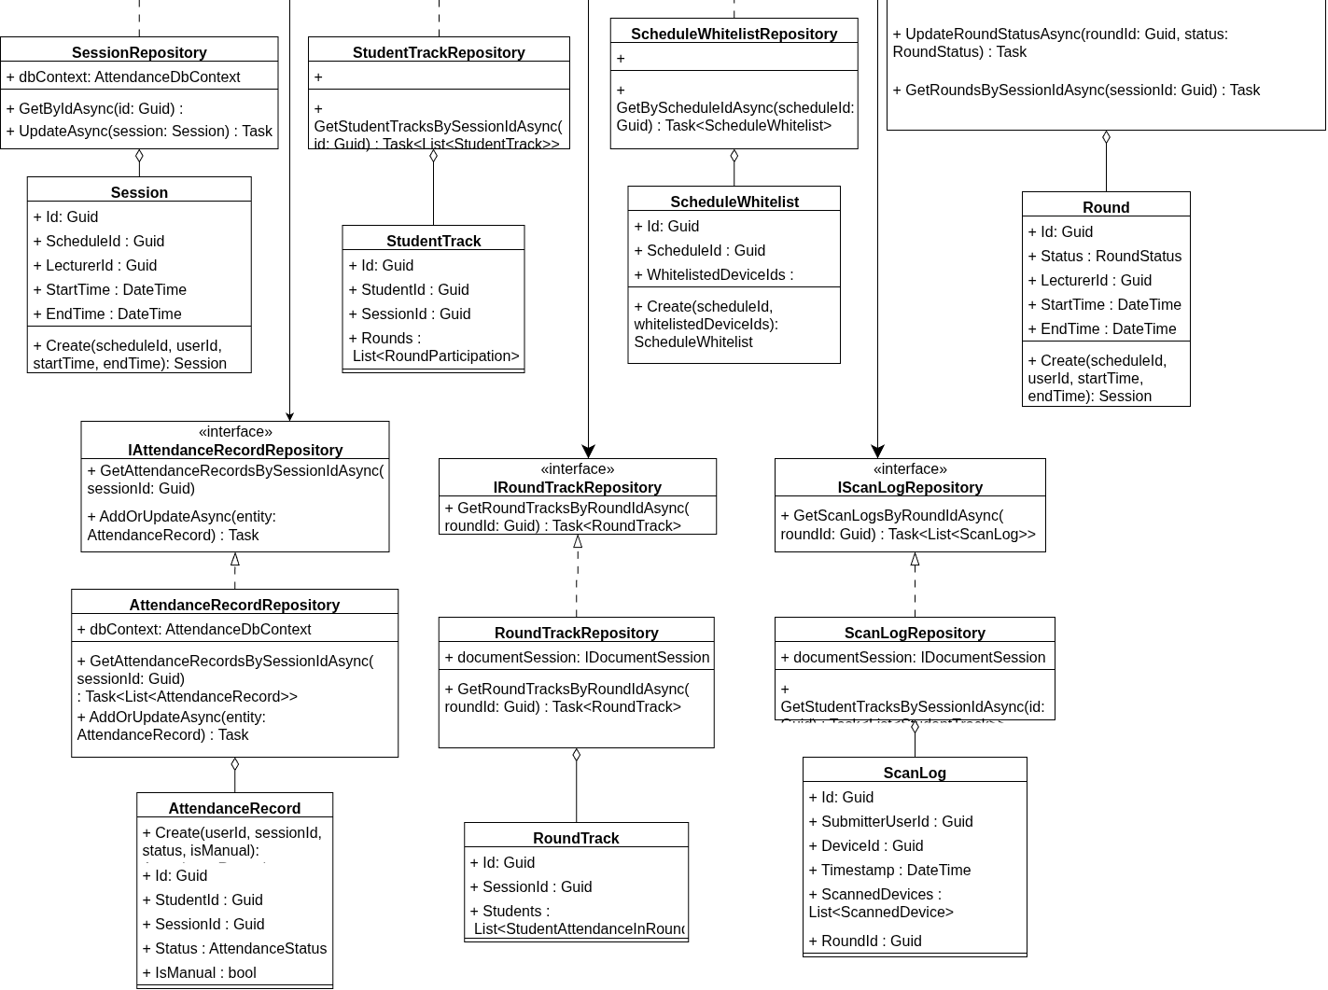
Figure 16 Attendance Calculation class diagram

3.1.2. Sequence diagram

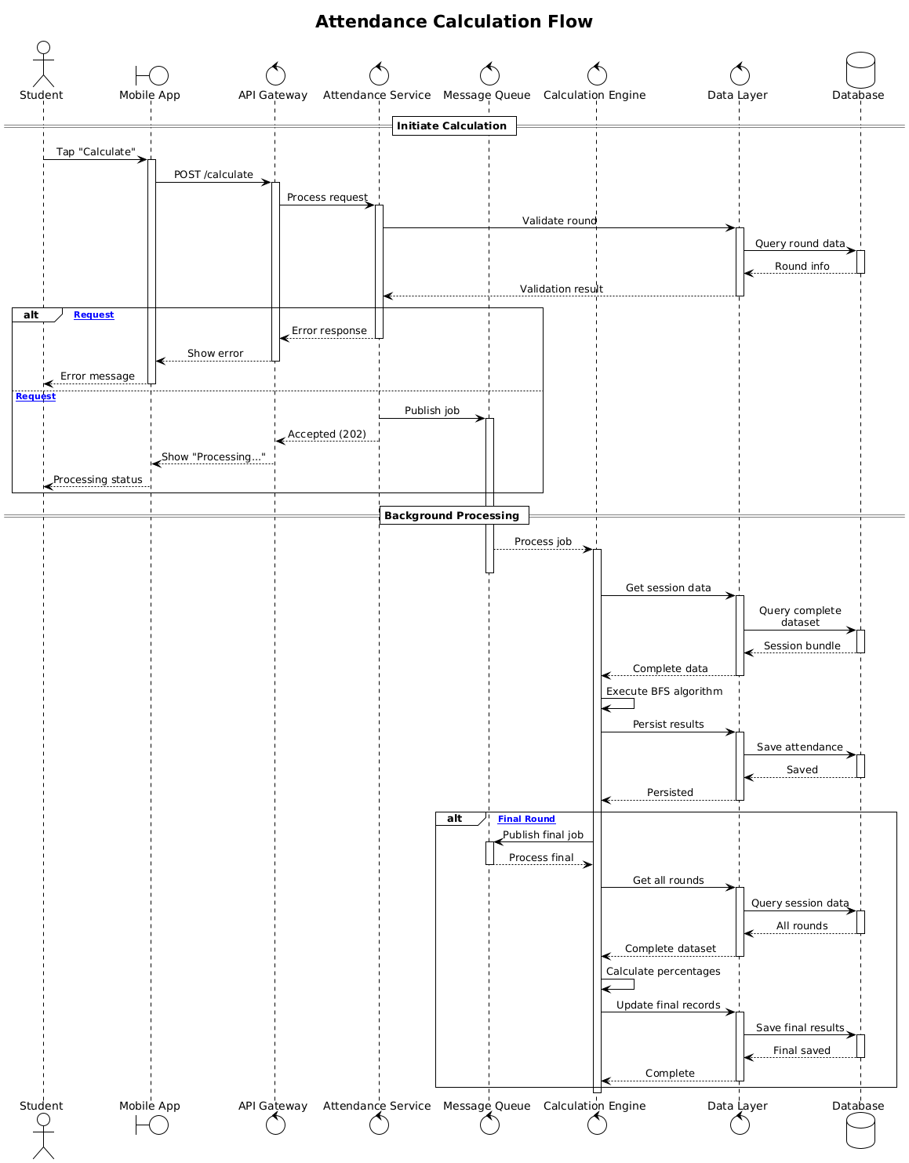
Figure 17 Attendance Calculation sequence diagram

3.2. FaceID verification

3.2.1. Class diagram

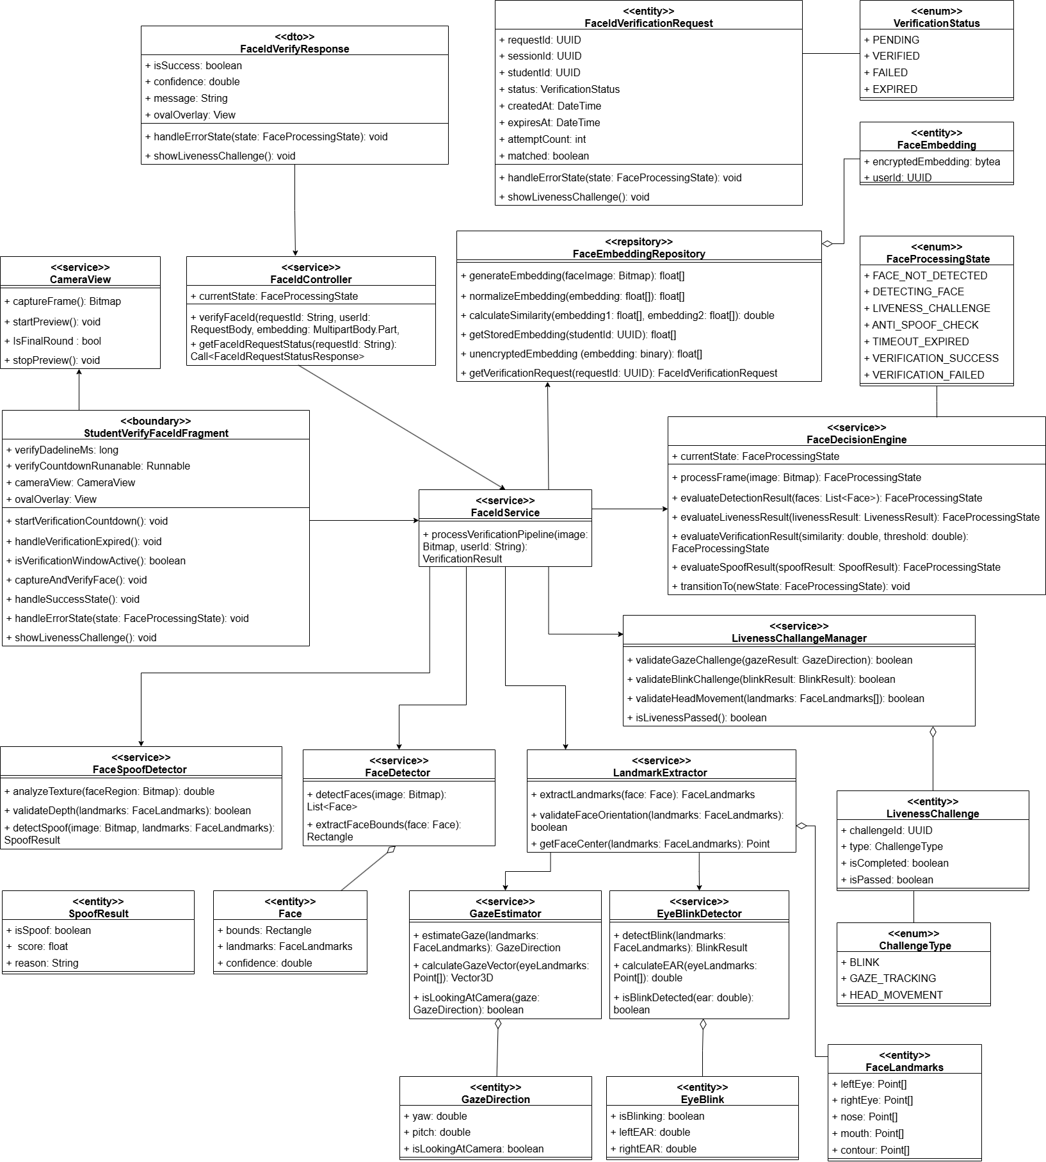
Figure 18 FaceID verification class diagram

3.2.2. Sequence diagram

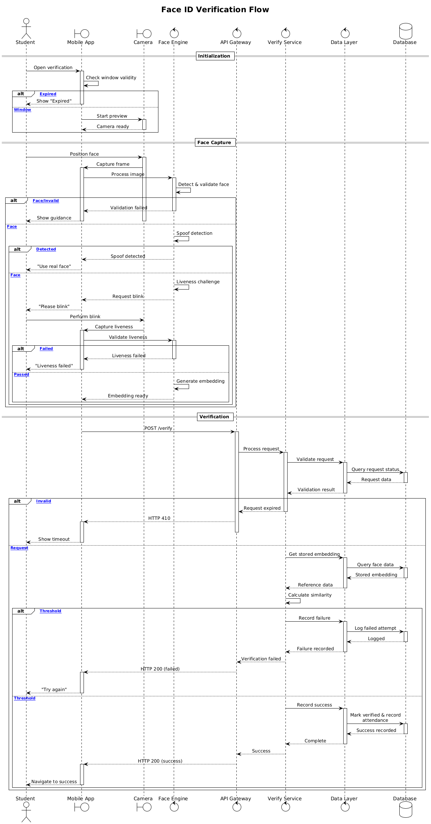
Figure 19 FaceID verification sequence diagram

4. Other Detailed Design

4.1 AI pipeline
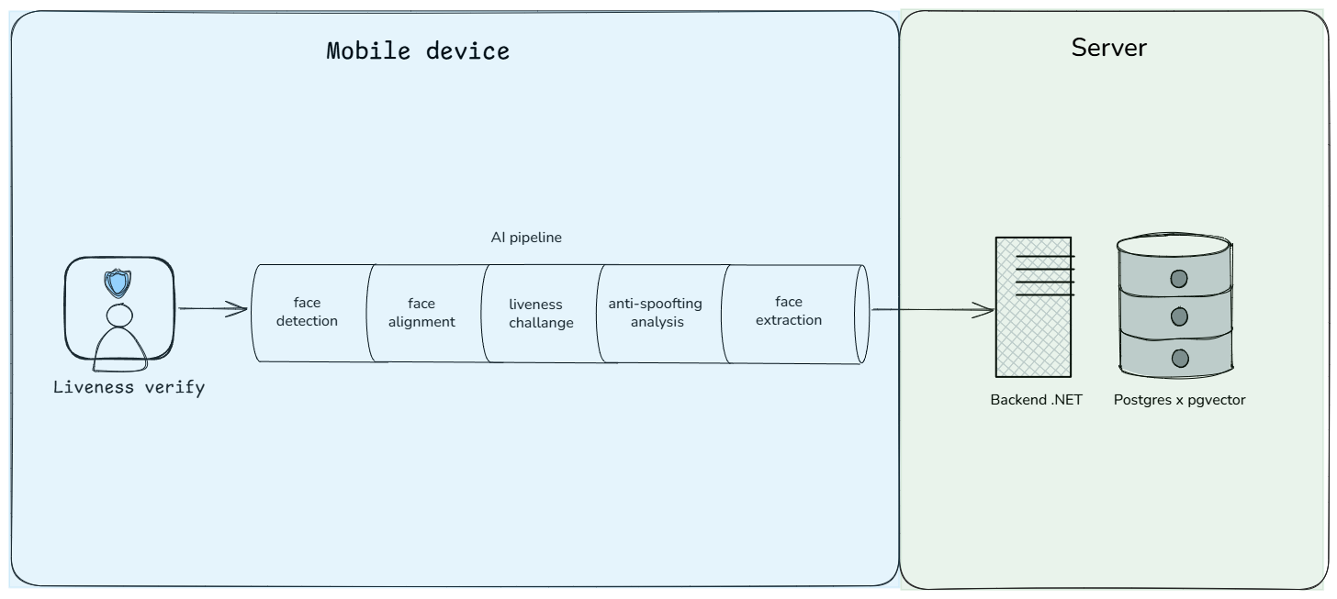
Figure 20 FaceID AI pipeline diagram

4.1.1 Overview
The AI face recognition pipeline implements a secure facial identification system with anti-spoofing and liveness detection capabilities. The system processes facial data through a sequential workflow that ensures authentic face verification while rejecting presentation attacks. The pipeline supports three primary operations: user registration, profile updates, and identity verification, all utilizing a standardized 512-dimensional embedding format for backend communication.

4.1.2 Face ID Verification
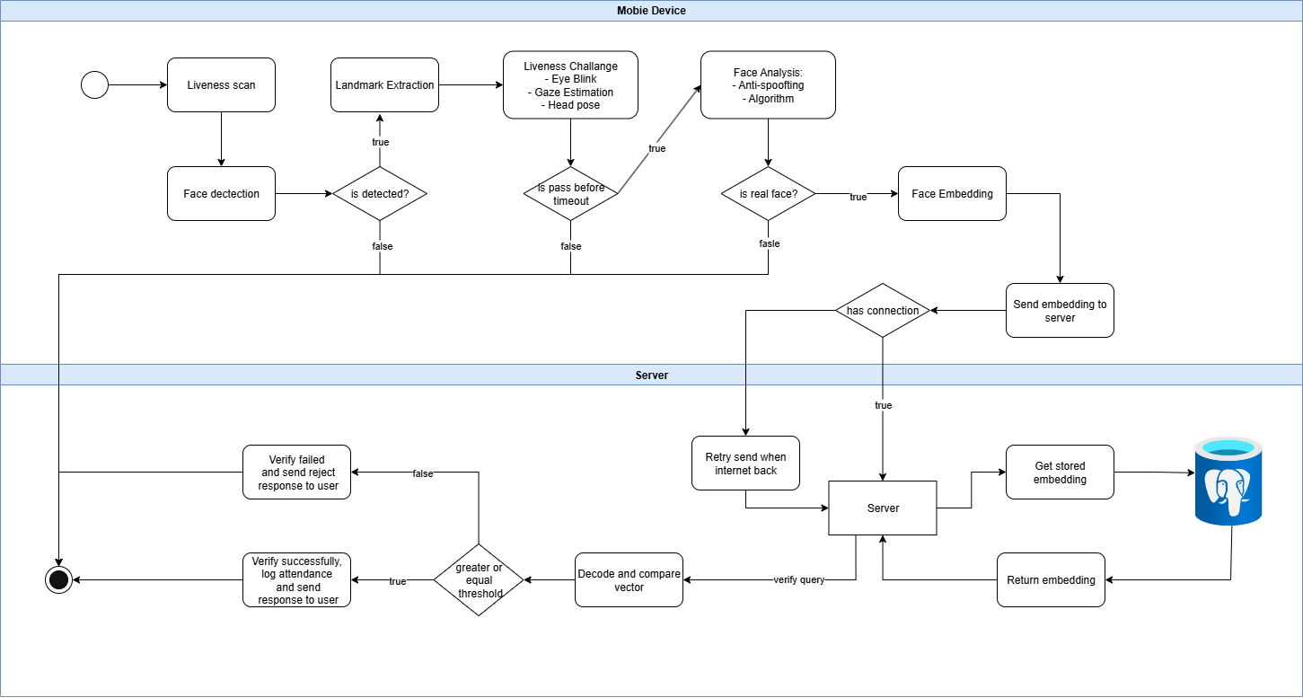
Figure 21 FaceID verification activity diagram

4.1.3 Pipeline Workflow Description
Stage 1: Face Detection and Initial Validation
The pipeline begins by capturing video frames from the camera input and processing them through a face detection algorithm. The system identifies facial regions within the frame and generates bounding boxes around detected faces. Only frames containing exactly one face proceed to the next stage - multiple faces or no face detection triggers appropriate user guidance messages. The detected face region is extracted and prepared for subsequent analysis steps.
Stage 2: Positioning and Alignment Verification
The system evaluates whether the detected face is properly positioned within the designated oval overlay area. This stage compares the face bounding box dimensions and center position against predefined tolerance thresholds. Faces that fall outside acceptable positioning parameters trigger guidance prompts directing users to adjust their position. Successfully positioned faces undergo facial landmark detection to identify key facial features including eyes, nose, and mouth for alignment purposes.
Stage 3: Anti-Spoofing Detection
The pipeline implements multi-scale anti-spoofing analysis to distinguish between genuine faces and presentation attacks. The system crops the facial region at two different scale factors (2.7x and 4.0x) and processes each through specialized deep learning models. These models analyze texture patterns, temporal variations, and other indicators of spoofing attempts including photographs, video replays, and screen displays. The system maintains temporal analysis across multiple frames to detect abnormal stability patterns and classification inconsistencies that indicate spoofing attempts.
Stage 4: Liveness Challenge Verification
Advanced liveness detection challenges users to perform specific actions proving they are physically present. The system implements two primary challenge types: blink detection and gaze direction following. Blink detection analyzes eye aspect ratios and eyelid movement patterns to verify natural blinking behavior. Gaze challenges require users to look in specific directions (typically right then left) with the system tracking eye movement through gaze estimation algorithms. Successful completion of liveness challenges enhances confidence in subsequent anti-spoofing decisions.
Stage 5: Frame Stabilization and Quality Assessment
The pipeline monitors facial positioning stability across multiple consecutive frames to ensure optimal image quality for embedding extraction. The system tracks variations in face center position and size, requiring minimal movement within defined thresholds before proceeding. A five-second analysis window collects quality scores derived from anti-spoofing confidence metrics, calculating statistical measures including mean and variance with outlier removal. Only faces meeting stability and quality criteria advance to the embedding extraction stage.
Stage 6: Feature Extraction and Embedding Generation
Stabilized facial images undergo preprocessing including resizing to 160×160 pixels and normalization to the [-1,1] value range. The processed images are fed into a FaceNet-based deep learning model that generates 512-dimensional feature vectors representing unique facial characteristics. These embeddings undergo L2 normalization to ensure consistent representation and are encoded in little-endian float32 format for backend API transmission.
Stage 7: Decision Integration and Result Processing
The final stage consolidates all pipeline outputs including anti-spoofing confidence scores, positioning compliance metrics, liveness verification status, and embedding quality assessments. The decision engine applies configurable thresholds specific to the operation type (registration, update, or verification) to determine final acceptance or rejection. Successful processing results in embedding transmission to backend services along with session metadata, while failures trigger appropriate error handling and user feedback mechanisms.
Temporal Processing and Adaptive Confidence
Throughout the pipeline, the system maintains temporal analysis capabilities that track behavior patterns across multiple frames. Post-liveness verification, the system implements adaptive confidence mechanisms that temporarily relax anti-spoofing thresholds to prevent false rejections while maintaining security integrity. This approach balances user experience with security requirements by leveraging the enhanced trust established through successful liveness challenges.
The entire pipeline operates within defined timeout parameters (30 seconds for face detection, 15 seconds for registration completion) and implements comprehensive error handling to ensure robust operation across varying environmental conditions and user behaviors

4.3 Model Description

4.3.1 Anti-spoofting model

4.3.1.1 Overview
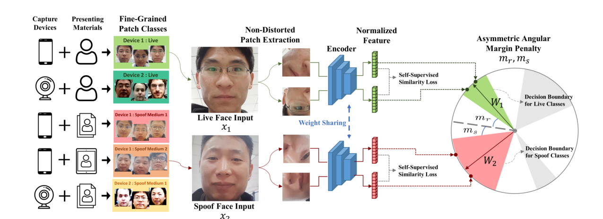
Figure 22 Patchnet learning Anti-spoofting architecture
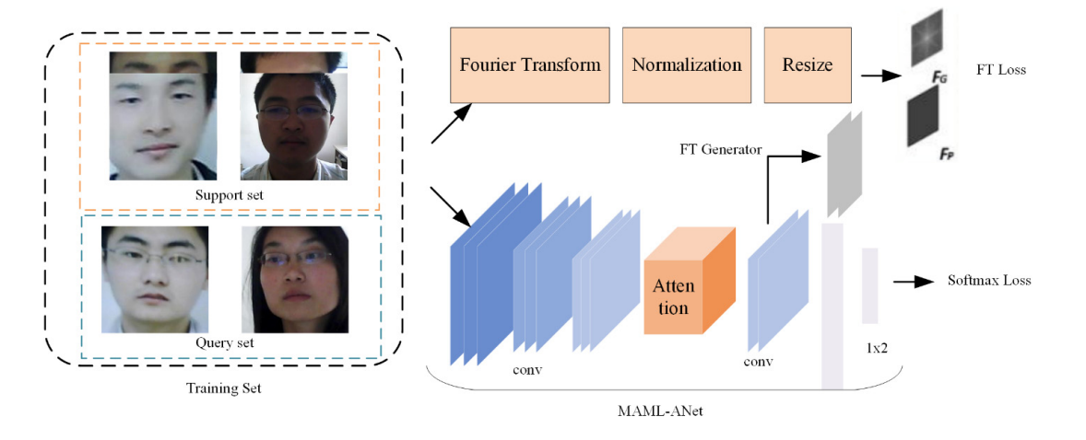
Figure 23 META learning Anti-spoofting architecture
The anti-spoofing models, PatchSFASNet-S2.7 and PatchSFASNet-S4.0, are advanced solutions designed to detect presentation attacks in facial recognition systems with high accuracy and robustness, optimized for real-time inference on resource-constrained mobile devices. These models integrate fine-grained patch recognition from PatchNet with meta-learning, attention mechanisms, and Fourier spectrum supervision from the Silent Face Anti-Spoofing (SFAS) framework, achieving superior performance on the NUAA dataset (AUC >0.995, F1 >0.95, EER <0.04) compared to baselines like MiniFASNet (AUC ~0.98) and SFAS (AUC 0.99, F1 0.90). The architecture employs a dual-branch design, consisting of a main classification branch and an auxiliary Fourier supervision branch, enhanced by Model-Agnostic Meta-Learning (MAML) for rapid adaptation to unseen attack types (e.g., deepfakes, high-resolution prints).
- PatchSFASNet-S2.7: Optimized for moderate zoom (scale 2.7), focusing on detailed facial regions such as eyes, nose, and mouth, with approximately 3.5 million parameters. It is suitable for detecting general spoofing attacks, including print and video replay attacks.
- PatchSFASNet-S4.0: Enhanced for deep zoom (scale 4.0), capturing micro-textures (e.g., pixelation, moiré patterns in high-resolution prints or deepfakes), with a similar parameter count. It excels in scenarios requiring high sensitivity to subtle spoofing cues.

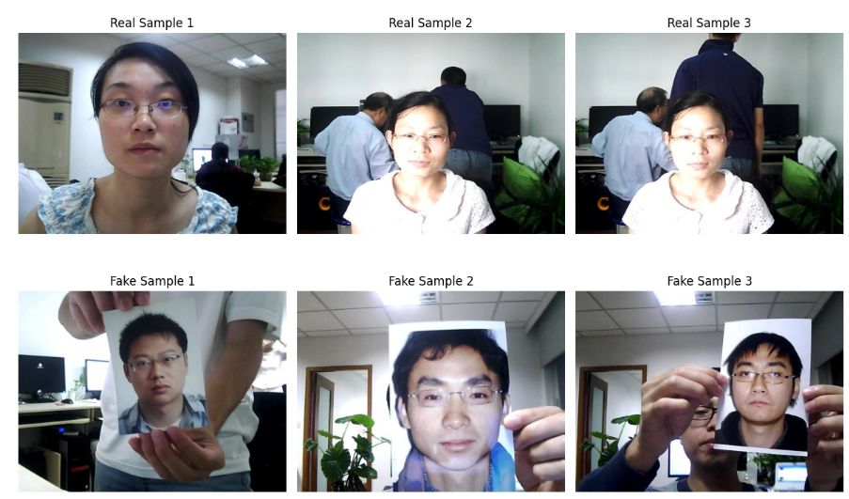
Figure 24 Sample Face Anti-Spoofing Dataset from NUAA

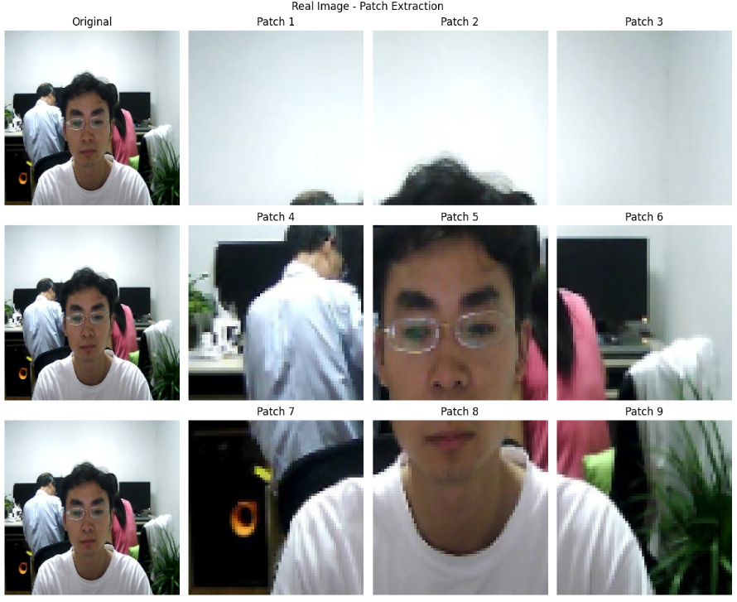
Figure 25 Sample Real Image - Patch Extraction

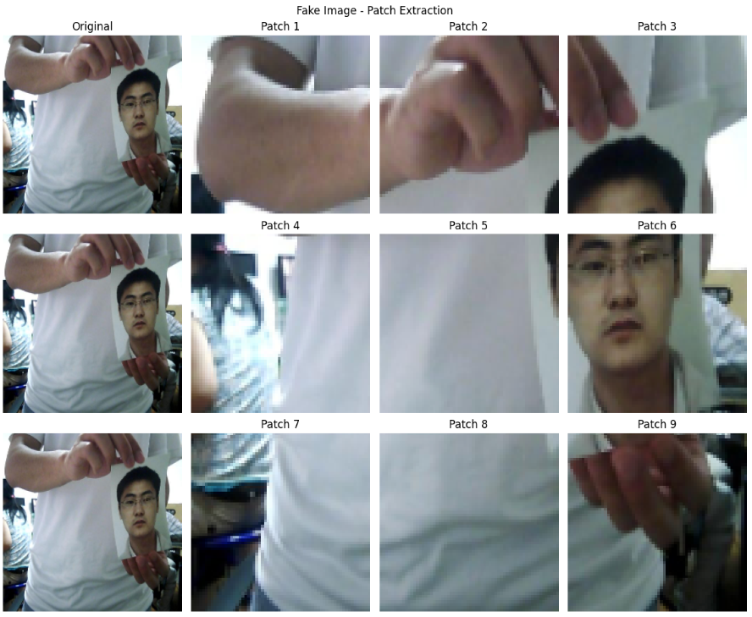
Figure 26 Sample Fake Image - Patch Extraction

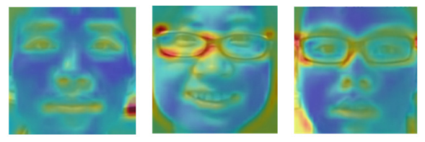
Figure 27 Thermodynamic diagram example of attention mechanism

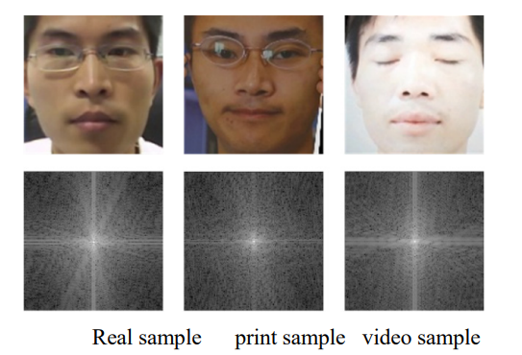
Figure 28 Fourier spectrum of face image(Top: input image, bottom: Fourier spectrum)

4.3.1.2 Architecture
The PatchSFASNet framework combines the lightweight EfficientFormerV2 backbone (from PatchNet) with advanced components from SFAS, creating a robust and efficient anti-spoofing system.
Main Classification Branch:
- Input Layer: Accepts RGB facial images of size 224×224 pixels, preprocessed at scales 2.7 or 4.0 during training to enhance data diversity and robustness.
- Convolutional Backbone: Utilizes EfficientFormerV2 (pretrained, ~3.5 million parameters), a Transformer-based architecture optimized for fine-grained patch recognition, capturing local spoofing cues such as texture artifacts.
- Attention Module: Implements a channel-wise attention mechanism (inspired by SFAS) to focus on critical facial regions (eyes, nose, mouth), reducing interference from background noise.
- Global Average Pooling: Reduces spatial dimensions while preserving feature information for efficient processing.
- Fully Connected Layer: Projects features into a 128-dimensional embedding space.
- Output Layer: Produces a binary probability distribution (live vs. spoof) using an asymmetric margin-based softmax loss (from PatchNet) to enhance generalization across diverse attack types.
Auxiliary Fourier Supervision Branch (Training Only):
- Input: 128-channel feature maps extracted from the main branch.
- Architecture: Computes Fast Fourier Transform (FFT) of input images and features, supervised by a Mean Squared Error (MSE) loss to capture frequency domain differences (e.g., high-frequency patterns at 45°/135° in live faces vs. horizontal/vertical in spoof faces).
- Purpose: Enhances feature learning by exploiting frequency domain cues, improving classification accuracy for subtle spoofing artifacts.
Meta-Learning (MAML):
- Framework: Model-Agnostic Meta-Learning (MAML) wraps the entire model, enabling few-shot adaptation (2-way 2-shot) to new attack types with minimal samples.
- Training: Employs inner and outer optimization loops to train on related tasks (e.g., varying lighting conditions, print distortions), ensuring robustness to unseen scenarios.
- Encoder:
The encoder leverages EfficientFormerV2’s Transformer-based layers to extract hierarchical features, critical for distinguishing live faces from spoofing attempts such as print, replay, or deepfake attacks.
Loss Function
The models are trained using a combined loss function, integrating classification and Fourier spectrum supervision:
- Classification Loss: Cross-Entropy (CE) loss with asymmetric margin-based softmax (from PatchNet) for binary classification (live vs. spoof), promoting robust feature clustering in the embedding space.
- Fourier Loss: Mean Squared Error (MSE) loss on Fourier spectra (from SFAS), weighted by a factor of 0.3 to balance supervision signals.
- Triplet Loss: Additionally, a Triplet Loss is incorporated (inspired by domain generalization FAS literature) to further enhance the embedding space by enforcing intra-class compactness and inter-class separation, particularly for live and spoof classes. (See LaTeX section below for formula.)
Combined Loss Function
Cross-Entropy Loss with Asymmetric Margin:
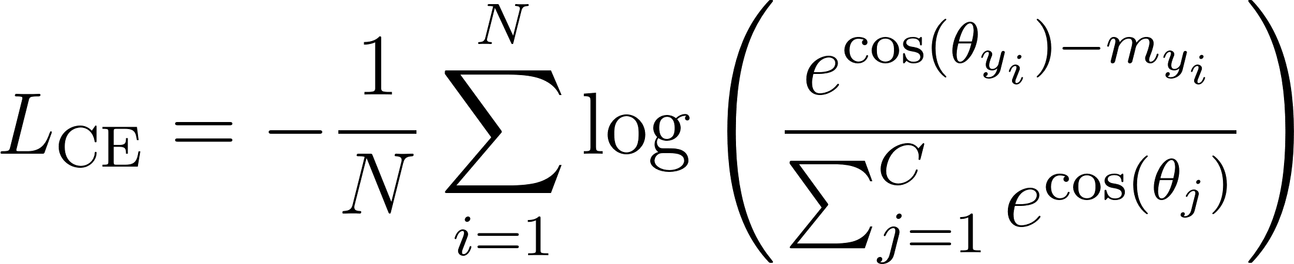
- : angle between feature vector and class weight for 
- : asymmetric margin (larger for live class)
- : number of classes (live, spoof)
- : batch size
Fourier Transform Loss:
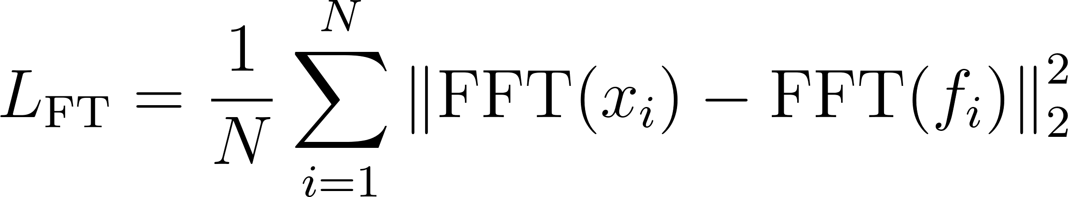
- : Fourier transform of input image
- : Fourier transform of feature map
- : batch size
Triplet Loss
- : embedding of anchor sample
- : embedding of positive sample
- : embedding of negative sample
- : triplet margin
Loss Weighting Factor:
- Fourier loss weight: 
- Triplet loss weight: 
Training Configuration
- Optimizer: Adam (learning rate=1e-5, beta1=0.9, beta2=0.999).
- Learning Rate Scheduler: Constant (no decay for short training duration).
- Batch Size: 4, with gradient accumulation (steps=4) to fit low VRAM constraints (e.g., 4GB).
- Total Epochs: 10, fitting within a 24-hour training constraint on Google Colab with T4 GPU.
Input
- Type: Facial images.
- Format: RGB images.
- Size: 224×224 pixels (after scaling and resizing).
- Channels: 3 (RGB).
- Preprocessing: Multi-scale crops at 2.7 (PatchSFASNet-S2.7) or 4.0 (PatchSFASNet-S4.0) during training, with scale 1.0 used for inference to optimize speed.
Output
- Type: Probability distribution over binary classes (live vs. spoof).
- Range: 0 to 1 (softmax activation).
- Classes: Live face, Spoof (encompassing print, replay, and deepfake attacks).
Key Technical Features
- Fine-Grained Patch Recognition: Inherits PatchNet’s approach to analyze local facial patches, enhancing detection of subtle spoofing cues.
- Meta-Learning Adaptation: MAML enables rapid adaptation to new attack types with few samples, improving cross-domain robustness by ~5-10% compared to baselines.
- Attention Mechanism: Focuses on critical facial regions, reducing false positives from background noise.
- Fourier Supervision: Leverages frequency domain analysis to improve discrimination of live vs. spoof faces, boosting AUC by ~0.01-0.02.
- Mobile Optimization: Approximately 3.5 million parameters, ~0.4G FLOPs, and inference time <50ms on mobile devices, exportable to ONNX/TFLite formats.

4.3.2 iTracker: Mobile Gaze Estimation Model

4.3.2.1 Overview
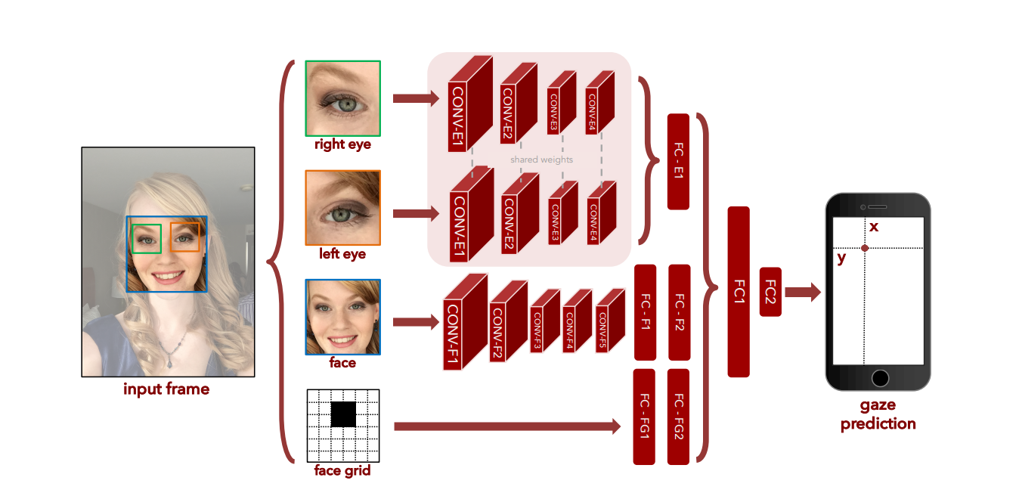
Figure 29 iTracker - Gaze estimation architecture

The iTracker model is a general-purpose gaze estimation CNN trained on the large-scale GazeCapture dataset, designed for mobile deployment with TensorFlow Lite. Unlike personalized approaches, iTracker achieves robust cross-user generalization without requiring individual user training, making it suitable for production applications.
Key Characteristics:
- Appearance-based CNN: End-to-end learning without hand-engineered features
- Cross-user Generalization: Trained on 1,474 subjects (2.5M frames) from the GazeCapture dataset
- Mobile Optimized: Real-time inference at 10-15fps on modern mobile devices
- Calibration Optional: Works uncalibrated with significant accuracy improvement via calibration
Performance Benchmarks (from CVPR 2016 paper):
- Uncalibrated: 1.71cm error (mobile phones), 2.53cm error (tablets)
- Calibrated (13 points): 1.34cm error (mobile phones), 2.12cm error (tablets)
- Frame Rate: 10-15fps on iPhone 6s with model compression

4.3.2.2 Architecture
Multi-Input CNN Architecture (from iTracker paper):
Full Model Inputs:
- Left Eye: 224×224×3 RGB crop
- Right Eye: 224×224×3 RGB crop
- Face: 224×224×3 RGB crop
- Face Grid: 25×25×1 binary mask indicating head location/size in frame
Compressed Model Inputs (for mobile deployment):
- Left/Right Eyes: 80×80×3 RGB crops (tighter facial landmark detection)
- Face: 224×224×3 RGB crop
- Face Grid: 25×25×1 binary mask
Encoder
Preprocessing:
- Face detection and cropping of left eye, right eye, and full face regions
- Face grid generation: 25×25 binary mask indicating normalized head position
- Image normalization to standard CNN input format
- Unified coordinate system: predicts gaze relative to camera position in centimeters
Feature Extraction:
- Separate CNN branches process each input modality
- Shared weights between left/right eye branches for parameter efficiency
- AlexNet-inspired layer dimensions with mobile optimization
Loss Function
Training Objective: Euclidean loss (L2/MSE) for 2D gaze coordinate regression:
where  represent predicted and ground truth coordinates in camera-relative space (centimeters).
Training Configuration:
- Framework: Caffe implementation
- Iterations: 150,000 with batch size 256
- Learning Rate: 0.001 → 0.0001 (reduced at 75k iterations)
- Optimization: Momentum 0.9, weight decay 0.0005

Calibration System
Optional Calibration using Support Vector Regression (SVR):
- Method: Extract features from FC1 layer, train per-user SVR mapping
- Calibration Points: 4, 5, 9, or 13 fixed screen locations
- Performance Improvement: 13-point calibration reduces error to 1.34cm (phones), 2.12cm (tablets)
- Implementation: Single SVR for joint (x,y) prediction or separate regressors
Input/Output Specifications
Input:
- Eye Images: 224×224×3 RGB (full model) or 80×80×3 RGB (compressed)
- Face Image: 224×224×3 RGB
- Face Grid: 25×25×1 binary mask
- Coordinate System: Camera-relative measurements
Output:
- Format: 2D coordinates (x,y) in centimeters relative to camera position
- Range: Typically ±20cm horizontally, ±25cm vertically based on device geometry
- Post-processing: Transform to screen coordinates using device-specific camera placement
Mobile Deployment Optimization
Model Compression (using dark knowledge distillation):
- Technique: Combine ground truth loss + teacher model predictions + feature matching
- Performance: ~0.05s inference time on iPhone 6s
- Memory: Reduced model size while maintaining accuracy
- Integration: Compatible with Apple's face detection pipeline for 10-15fps overall
Key Advantages Over Personalized Approaches
- No User Training Required: Works out-of-box for new users
- Large-Scale Training: Leverages diverse 1,474-subject dataset for robustness
- Cross-Dataset Generalization: Features transfer well to other gaze datasets
- Production Ready: Suitable for commercial deployment without per-user setup
Limitations
- Calibration Beneficial: While functional uncalibrated, calibration significantly improves accuracy
- Lighting/Pose Sensitivity: Performance degrades under extreme conditions despite training diversity
- Device Dependency: Requires accurate camera position measurements for coordinate transformation

4.3.3 FaceNet Model Description

4.3.3.1 Overview
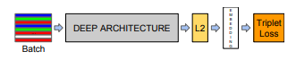
Figure 30 FaceNet model structure
FaceNet is a deep learning model designed for face verification, recognition, and clustering. It learns a direct mapping of face images to a compact Euclidean space, where the squared L2 distance between embeddings corresponds to a measure of face similarity. This allows for efficient and scalable face recognition using standard techniques like thresholding, k-NN, and k-means clustering on the generated embeddings.
The model is trained using a triplet loss function, which minimizes the distance between an anchor and a positive sample (same identity) while maximizing the distance between the anchor and a negative sample (different identity). While the original paper achieved state-of-the-art performance with 128-dimensional embeddings, the provided repository also contains models that produce 512-dimensional embeddings. The model has demonstrated exceptional performance on benchmarks like Labeled Faces in the Wild (LFW) and YouTube Faces DB.

4.3.3.2 Architecture
The FaceNet architecture is based on a deep convolutional network (CNN). The models in the repository primarily use an Inception ResNet v1 architecture, which combines the strengths of the Inception architecture with residual connections.
- Input Layer: The model typically takes a 160x160 pixel face image as input. This image is pre-whitened (standardized) before being passed to the network.
- Convolutional Layers: A deep stack of convolutional layers, including Inception modules and residual connections, extracts hierarchical features from the face image.
- Residual Connections: These are integral to the Inception ResNet v1 architecture, improving training efficiency and enabling deeper networks by mitigating the vanishing gradient problem.
- L2 Normalization: The output embedding is L2-normalized to ensure all embeddings lie on a hypersphere of radius 1. This is a critical step for using squared L2 distance as the similarity metric.
- Embedding Layer: The final layer is a fully connected layer that outputs a 128-dimensional or 512-dimensional vector, which represents the face embedding.
- Output Layer: There is no traditional output layer for classification. The final output is the embedding vector itself, which is then used for distance comparisons.

Encoder
The FaceNet encoder transforms a facial image into a compact Euclidean embedding. This process ensures that faces of the same person are mapped to nearby points in the embedding space, while faces of different people are mapped far apart.
- Image Preprocessing: The input image is first processed by a face alignment method like MTCNN to detect and crop the face. The cropped image is then resized to 160x160 pixels. Finally, the image is pre-whitened by subtracting the mean and dividing by the standard deviation across each channel. It is not normalized to.
- Feature Extraction: The preprocessed image is passed through the deep Inception ResNet v1 network to extract discriminative facial features.
- Embedding Generation: The features are projected by a fully connected layer to produce a compact 128-D or 512-D embedding vector. The embedding is then L2-normalized.

Objective Function
FaceNet is trained using a triplet loss function designed to enforce a margin between pairs of faces from the same identity and pairs of faces from different identities. The objective is to satisfy the triplet constraint for all possible triplets of anchor, positive, and negative samples.
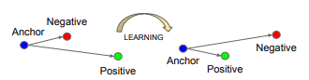
Figure 31 FaceNet model triplet loss
The loss function is defined as:
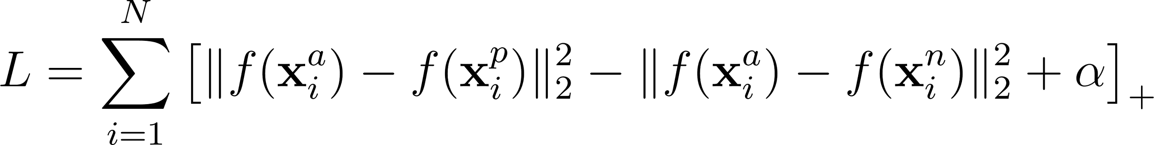

4.3.4 Face Detection MediaPipe

4.3.4.1 Overview
BlazeFace is a lightweight face detection model that detects faces in images or video streams, even in real-time with low-latency, on mobile devices. It is optimized for on-device performance, which is key for your project, especially if it's designed to run on mobile platforms.
Key Features:
- Speed: BlazeFace is designed to be fast, making it ideal for real-time face detection on mobile devices and other low-power devices.
- Accuracy: It can detect faces in various poses and lighting conditions, with high precision.
- Robustness: The model is resilient to different facial orientations, including those at various yaw, pitch, and roll angles.
- Scalability: It is capable of detecting multiple faces simultaneously in a single frame.

4.3.4.2 Architecture:
BlazeFace is based on a lightweight CNN architecture with mobile-optimized layers. The model utilizes the Single Shot Multibox Detector (SSD) framework for object detection, which helps detect faces in real-time.
The model outputs the bounding boxes around faces, which are then passed to the Face Landmark Detection module.
Input:
- Face Image: Input images are typically resized to 320x320 pixels to fit the model’s expected input size.
- Preprocessing: The input image is normalized to fit the model's requirements.
Output:
- Bounding Box Coordinates: For each detected face, BlazeFace returns the bounding box coordinates (x_min, y_min, x_max, y_max) in the image, denoting the location of the face.
- Confidence Score: A score indicating the likelihood that a detected face is valid.
Performance:
- Inference Time: BlazeFace achieves real-time performance on mobile devices with ≤ 50 ms per frame, enabling smooth interaction for applications requiring low-latency face detection.

4.3.5 Face Landmark MediaPipe

4.3.5.1 Overview
MediaPipe Face Landmarker performs detailed facial landmark detection using a regression-based neural network. It processes face regions detected by BlazeFace to extract precise 3D coordinates of facial features, enabling advanced applications like gaze estimation, expression analysis, and augmented reality effects.
Key Features
- High-Resolution Landmarks: Detects 468 3D facial landmarks with sub-pixel precision
- Real-time Processing: Optimized for live video processing on mobile devices
- 3D Coordinate Output: Provides depth information for enhanced spatial understanding
- Expression Analysis: Generates blendshape coefficients for facial expression recognition
- Robustness: Maintains accuracy under varying lighting, poses, and partial occlusions

4.3.5.1 Architecture
- Model Type: Regression-based convolutional neural network
- Input Processing: Processes face crops from BlazeFace detection
- Multi-task Output: Simultaneous prediction of landmarks, blendshapes, and transformation matrices
- Optimization: Mobile-friendly architecture with efficient inference

Input Specifications
- Source: Face regions detected by BlazeFace
- Image Format: RGB face crops
- Preprocessing: Face alignment, resizing, and normalization
- Resolution: Variable input size based on detected face dimensions

Output Specifications: 468 3D Facial Landmarks
- Coordinate System: 3D coordinates (x, y, z) in normalized image coordinates
- Landmark Distribution:
- Face oval: 17 points
- Eyebrows: 18 points (9 per eyebrow)
- Eyes: 24 points (12 per eye)
- Nose: 27 points
- Mouth: 20 points
- Face contour and additional detail points: 362 points
- Precision: Sub-pixel accuracy for landmark positioning

Blendshape Coefficients
- Expression Coefficients: 52 blendshape scores representing facial expressions
- Range: Normalized values (0.0-1.0) indicating expression intensity
- Applications: Emotion recognition, avatar animation, expression transfer
Transformation Matrices
- Face Pose Matrix: 4×4 transformation matrix for face orientation
- Applications: AR effects, face alignment, pose estimation
- Coordinate System: Camera coordinate system transformation
Performance Characteristics
- Inference Time: Real-time processing capability on mobile devices (~30ms per face)
- Accuracy: High precision with sub-pixel landmark localization
- Robustness: Maintains performance under challenging conditions:
- Partial occlusions (glasses, masks, hands)
- Extreme lighting variations
- Head pose angles up to ±90 degrees
- Multiple face orientations

